Ride Participant Guide
Want to ride with Hardwood Next Wave? Here’s what you need to read and understand before you ride.
Overview
Every ride will have a Ride Leader
- Obey the Ride Leader. They have been educated on the rules of the road and are there to help keep the ride fun and safe.
- You do not need to stay in a ride if you do not feel comfortable. Inform the ride leader if you are leaving the ride.
Ride Formation
- Group size will be no more than 25 riders. Groups larger than 25 riders will be split into smaller groups separated by 100m on the road.
- Group formations will be;
- Double Paceline – 2 lines of riders passing on the left and staying as tight to the right side of the road as safely possible.
- Single Paceline – single line of riders for busier roads or when space is limited. Large group should split into groups of 10 to allow for easier passing by vehicles.
Share the Road
- Be courteous to all road users
- Show your appreciation to courteous drivers with a friendly wave and smile.
- Allow motorists to pass when safe to do so. Do not indicate to the driver when it is safe to pass.
- Be careful not to startle other road users. Indicate your presence and pass when safe to do so.

Obey the Highway Traffic Act (HTA)
- Cyclists have the same rights and responsibilities as a driver.
- Cyclists must obey all traffic laws.
- Cyclists must stop at stop signs.
- Cyclists must pull over to the right and stop for emergency vehicles.
- Cyclists must use lights within 30 minutes of dusk or dawn and during poor visibility. White on the front, red on the back
Other Safe Practices
- Be aware of your surroundings at all times.
- Use of a rear red light is recommended at all times but please use the solid red mode while riding in a group.
- Be prepared for the ride.

Rider Guidelines
All Hardwood Next Wave rides are meant to be fun and safe! Riders that break any guidelines or threaten the safety of other riders will be asked to leave the ride and may face sanction by Hardwood Next Wave.

What to bring to the ride
- Helmet - safety standards association approved helmets are mandatory while riding.
- Bike - must be in good working order with front and rear brakes functioning properly.
- Water bottles - soft type only; no hard plastic, glass or metal bottles are allowed.
- Front and Rear lights
- Water and Food
- Spare Tube, CO2 or pump, multitool
- Money, Identification and Cell Phone
Ride Etiquette
- Please arrive on time and ready to ride at the scheduled ride time.
- Ride predictably - do not brake suddenly, swerve uncontrollably or overlap wheels with other riders.
- Call out obstacles, debris or other potential hazards to the group. Every member has a “duty of care” to all members.
- Call out and indicate with hand signals changes of direction and when stopping. Only change direction when it is safe for the group to change direction.
- Railway crossings - call out tracks ahead, reduce speed and cross the tracks at a right angle when safe to do so. Remember that tracks are very slippery when wet.
- Share the road - be courteous to all road users, follow the directions of the ride leader and never cross the yellow line.
- When stopped move completely off the road and clear of intersections.
- Let the ride leader know if you are leaving the ride.
When things go wrong
- Weather – rides will be cancelled prior to the start of the ride if severe weather or lightning is forecasted or occurring. If you encounter severe weather or lightning during the ride seek immediate shelter.
- Accidents – the group stops and moves completely off the road, care administrated to the injured rider or riders and the ride leader will call 911 if necessary.
- Mechanical – the group stops and moves completely off the road, assist with the repair if possible.
Paceline Function and Formation
We use two formations for group riding – double and single paceline. The ride leader will call out the appropriate formation for the needs of the group and to accommodate the needs of other road users. Communication among riders is key to a smooth and safe paceline. When riding in a paceline always stay alert to the riders and your surroundings. Always keep your eye on the back of the rider in front of you, never on the riders rear wheel.
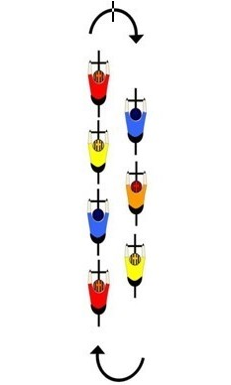
Double
- Riders on the left pass the riders on the right
- Speed must be kept constant, no accelerations
- Riders at the front call out changes in directions,
stopping and road hazards
- Riders in the middle stay alert and relay messages
to the riders behind them
- Riders at the back monitor traffic from behind and
ensure riders are not dropped from the group

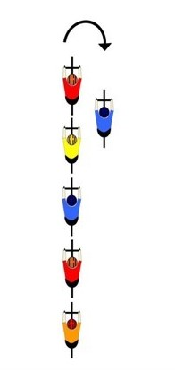
Single
- Same etiquette as a double paceline
- Use when road is narrow or traffic requires space
to safely pass.
- Paceline must be less than 10 riders long. Larger group
broken into smaller pacelines separated by 100m on the
road.

